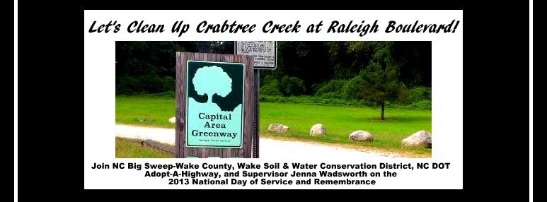
Wake County Big Sweep Clean Up on the National Day of Service and Remembrance
Come help us clean up Crabtree Creek at Raleigh Blvd on the National Day of Service and Remembrance, September 11. Adult volunteers (aged 18 & over) are invited to join the Wake County Soil and Water Conservation
District, NC Big Sweep–Wake County, and NCDOT Adopt-A-Highway at 9:00 am to clean litter from Raleigh Blvd. before it enters Crabtree Creek.
WHO we need: ADULT VOLUNTEERS WELCOME!
WHEN to meet: 9:00 am to 11:30 am is when we will be cleaning up our community. Please plan to arrive at least 15 minutes prior to that so we can meet, discuss our goals and plans and site rules, and walk together over to the site.
WHERE: Meet us at the Middle Crabtree Creek Greenway parking lot on Crabtree Blvd. for instructions and supplies. (Directions can be found further down)
WHAT we are bringing: Gloves, trash bags, safety vests, data cards, and litter reachers will be provided. All volunteers must sign a Big Sweep liability waiver to participate. We will have extra copies of the waiver on-site for your to fill-out.
WHAT you should wear & bring: Wear old clothes and closed-toe shoes that are comfortable for walking. Bring drinking water, hat, sunscreen, and--if you need it--insect repellent. You might even want to bring a towel if you're the sweaty type...
HOW to get involved: Adult volunteers are asked to please pre-register by contacting Wake Soil and Water Conservation District Supervisor and Big Sweep Zone Captain Jenna Wadsworth at jenna@jennawadsworth.com or Wake County Big Sweep at 919-250-1065 or sbjones@wakegov.com. All volunteers must sign a Big Sweep liability waiver to participate. We will have extra copies of the waiver on-site for your to fill-out.
DIRECTIONS: From I-440 Beltine, take exit #11A Capital Blvd. south towards downtown. Turn left onto Crabtree Blvd. Continue straight, then turn right into Middle Crabtree Creek Greenway parking lot. Meet here at 9:00 am sharp at the latest. (For a street address, use that of the Parkview Building next to greenway parking lot at 2321 Crabtree Blvd., Raleigh, NC 27604. Be sure to park in the greenway parking lot and not in the Parkview parking lot as it’s reserved for customers.)

